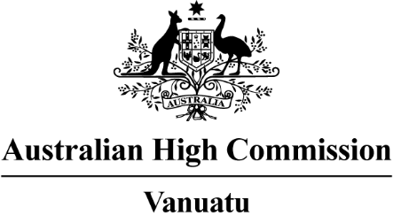
Candidate Guidance on How to Apply

We are currently recruiting for positions with our Development Cooperation section including a Senior Aid Communications Officer (Level 7) Senior Program Manager (Level 7 and Level 6) Program Manager (Level 5) and Assistant Program Manager (Level 4).
Full-time, part-time and ongoing and non-ongoing positions
Closing date: 28 February 2021
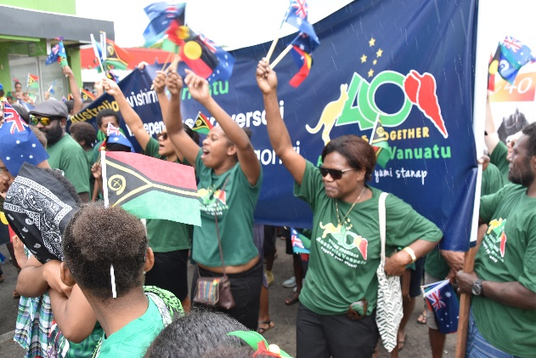
About the Australian High Commission in Port Vila
The Australian High Commission in Port Vila manages the Australian Government’s presence in Vanuatu. We promote Australia’s interests, facilitate international trade and investment, deliver development assistance, respond to crises and provide services to Australian citizens. Details of our Department's work, as well as our purpose, outcomes and priority functions can be found on our website www.vanuatu.embassy.gov.au.

About Australia’s Development Cooperation Program in Vanuatu
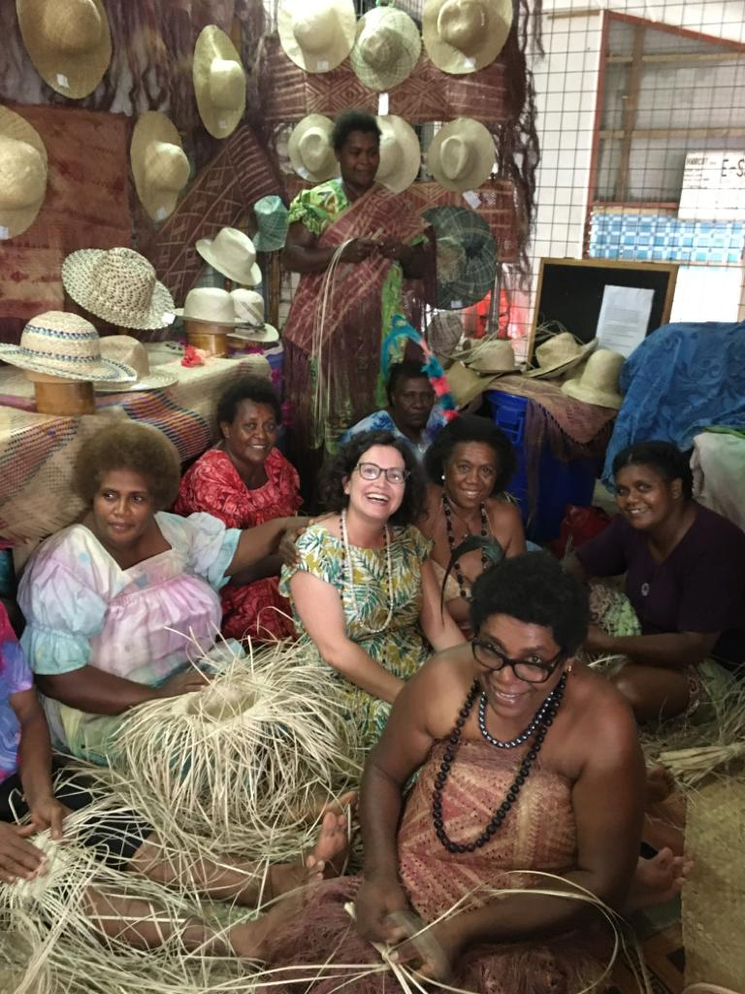
Australia is Vanuatu’s largest bilateral development partner. We work with the Government of Vanuatu to further Vanuatu’s development as outlined in the National Sustainable Development Plan and Australia’s Partnerships for Recovery Strategy: Australia’s COVID-19 Development Response.

Australia’s core focus in Vanuatu is supporting health security, stability and economic recovery, and protecting the most vulnerable. Key sectors where we work include health, education, skills, governance, infrastructure, policing and justice and gender.

Australia is also committed to helping Vanuatu respond to COVID-19, to recover from the impacts of Tropical Cyclone Harold, and to prepare for and respond to future humanitarian emergencies, including in line with the Vanuatu Recovery Strategy 2020-2023, Yumi Evriwan Tugeta.

The program is delivered in partnership with key Vanuatu government ministries and a diverse range of NGO, multilateral and other partners.

The application pack includes the following information and guidance for candidates
- An overview of the position details
- Selection criteria questions for candidate response to be included with the application.
- Guidance on how to apply, including referee requirements.

Position Details – An Overview
We are looking for highly motivate professionals to join the team, we have exciting opportunities in various sectors of our programs. This is an opportunity to join a strong team environment and to learn and develop in the field of program management while gaining experience and expertise working with the largest donor partner in Vanuatu.

Senior Program Managers (Level 7 and Level 6)
Under limited direction, the Senior Program Manager will lead a small team to manage one or more sectors of the aid program in Vanuatu. The role requires providing high-level strategy, policy and program advice to senior managers in the Australian Government and to partners in Vanuatu.
Key skills required of the position:
- Leadership and initiative
- Strategic thinking
- Strong representational ability
- Excellent communication skills, including strong writing skills
- Strategic thinking and initiative to guide program direction and monitor, improve programs
- Work well in a team

Program Managers (Level 5)
Under general direction, the Program Manager provide support for the management of one or more sectors of the aid program in Vanuatu. Program Managers also support improved coordination and reporting (financial, fraud, performance and quality) across the program.
Key skills required of the position:
- Strong program administration skills
- Strong communication skills, including writing skills and quality reporting
- Strong representation skills
- Ability to provide strong logistical support across all program areas
- Work well in a team

Assistant Program Manager (Level 4)
Under general direction, the Assistant Program Manager support delivery of the aid program together with implementing partners. The role undertakes a range of moderately complex program management and administration tasks.
Key skills required of the position:
- Strong administration skills
- Good communication skills, including good writing skills
- Ability to provide logistical support across all program areas and support the team
- Ability to establish and maintain good working relationships
- Work well in a team

Senior Aid Communications Officer (Level 7) – six-month contract
Under limited direction, the Senior Aid Communications Officer will work within the Australian High Commission’s Public Diplomacy Unit to promote Australia’s development cooperation program in Vanuatu. They will produce aid-focused communications materials including media releases and social media posts and will provide training and capacity building to communications and public affairs staff employed within Australia’s bilateral aid programs in Vanuatu.
Key skills required of the position:
- Leadership and initiative
- Strategic thinking
- Strong representational ability
- Excellent communication skills, including strong writing skills
- Work well in a team

In the event of a disaster all program levels may be required to be part of the post disaster response team.

Further information about the positions including Position Descriptions and salary details can be can be found on the following links and on our website www.vanuatu.embassy.gov.au.
- Senior Program Manager
- Program Manager
- Assistant Program Manager
- Senior Aid Communications Officer

SELECTION CRITERIA QUESTIONS
As part of your application we require a response to the following questions outlining how you meet each selection criteria (limited to 3 typed pages). Your responses will be used to assess your suitability for the position as part of our shortlisting process.

Selection Criteria Questions for Senior Program Manager
- Outline your qualifications, skills, knowledge and experience in one or more (maximum of 3) of the sectoral focus areas listed in the position description.
- A key aspect of this role is to develop and maintain strong working relationships with stakeholders. Please provide an example of your experience managing professional relationships.
- Describe a recent achievement or activity that you were responsible for completing and that you are particularly proud of.

Selection Criteria Questions for Program Manager and Assistant Program Manager
- Why you are suitable for this role? (You may wish to include details of your work experience and study).
- A key aspect of this role is to support strong working relationships with stakeholders. Can you provide details of your experience managing professional relationships?
- Outline your experience in contracting, financial management and/or monitoring and evaluation of activities?

Selection Criteria Questions for Senor Aid Communications Officer
- Please provide details of your qualifications and professional experience at a senior level in a communications or management role?
- Please provide details of your experience in representation and developing and maintaining strong, high-level professional networks?
- Outline your experience in developing and implementing a communication strategy and/or high-level reporting product?

HOW TO APPLY

Apply Online
Applications for this role must be submitted using the link below. Do not email your application. Please click on the link below to download the Job Description which includes details on how to apply online.

For more information and to apply, click here or visit www.linkps.com

Applicants should be citizens of Vanuatu or hold residency status that permits work in Vanuatu.

Only those candidates considered suitable for interview will be contacted.
The Australian High Commission is an equal opportunities employer.

